**Expt No 08:**

Create a simple cloud web application for student counselling system using any Cloud Service Provider to demonstrate SaaS with the fields of student name, age, address, phone, subjects studied, Year of passing, percentage of marks, domain interest, etc.

**Date:** 22/02/2024

**Aim:**

To Create a simple cloud web application for student counselling system using any Cloud Service Provider to demonstrate SaaS with the fields of student name, age, address, phone, subjects studied, Year of passing, percentage of marks, domain interest, etc.

**STEP 01:**

Open a Zoho web application and click a Create a New application and Create a New Component And select a Component Type as Form Type.

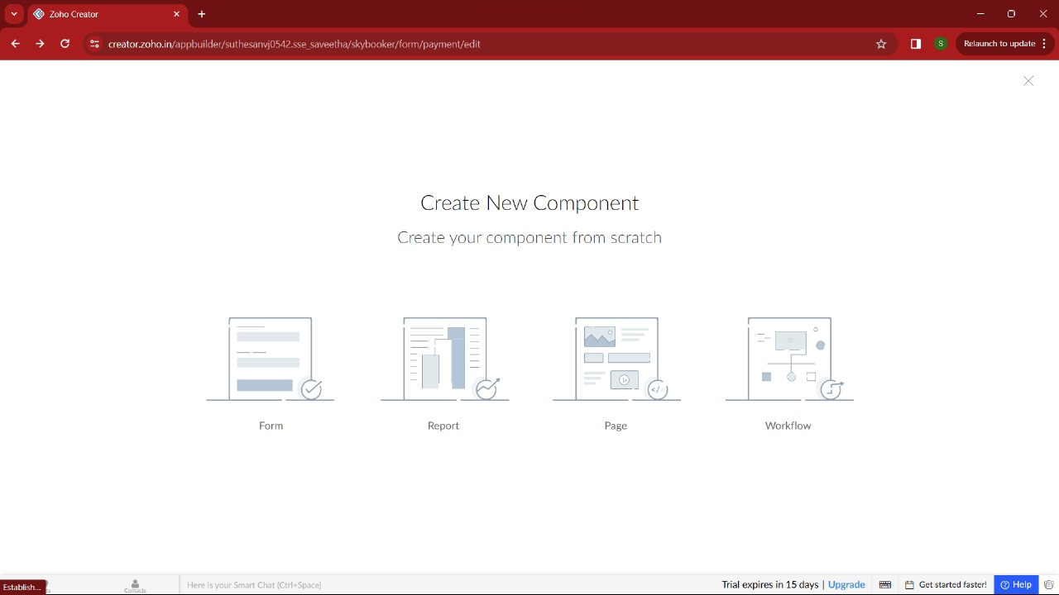

**STEP:02** Start To a Create a Form from Scratch

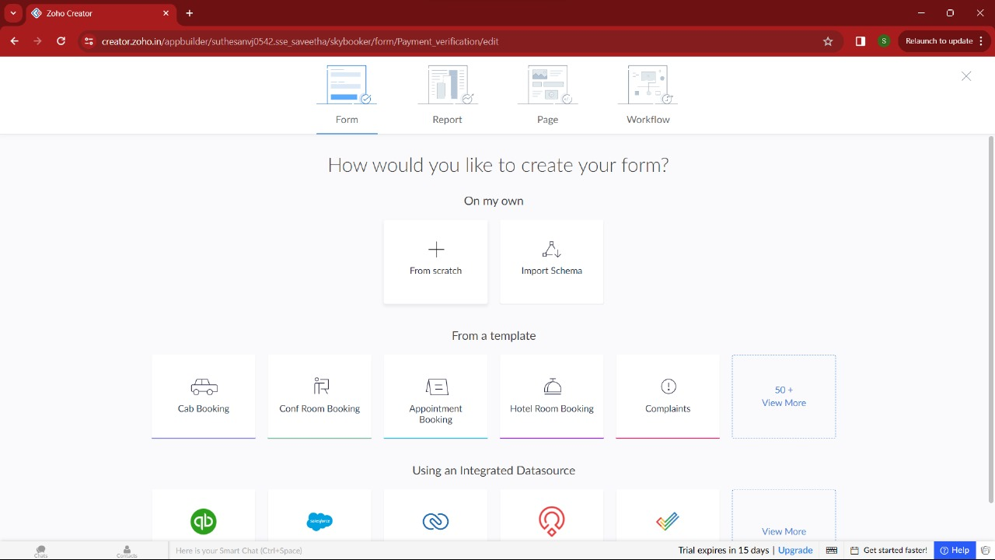

**STEP 03:** To Give a Name For Your Form and click a Button Create From Scratch

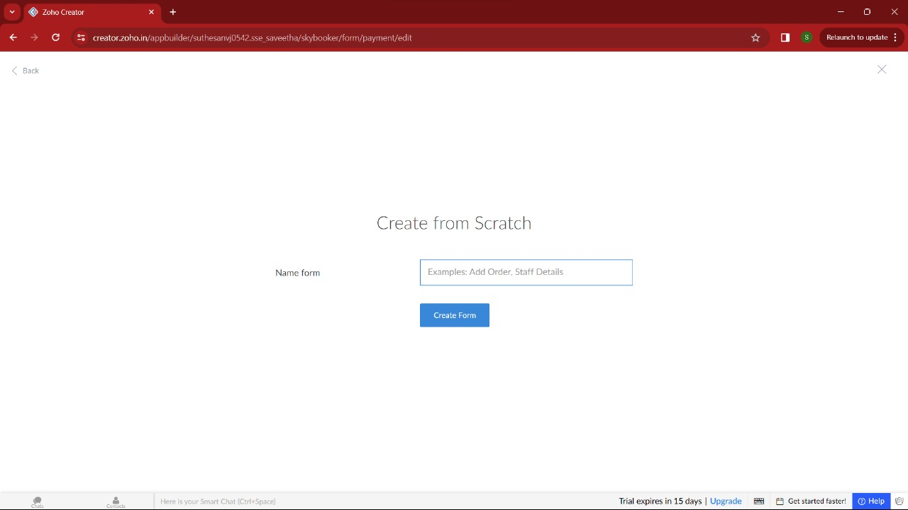

**STEP 04:** Create a login Form

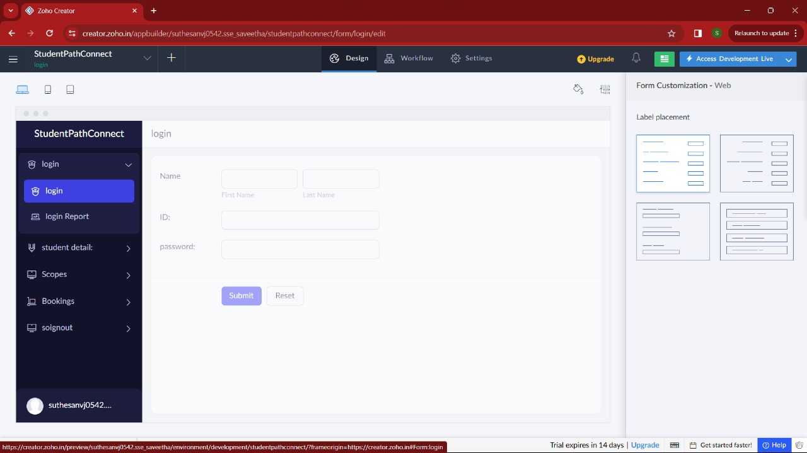

**STEP 05:** Then I added another form namely Student Details For Counselling Purpose.

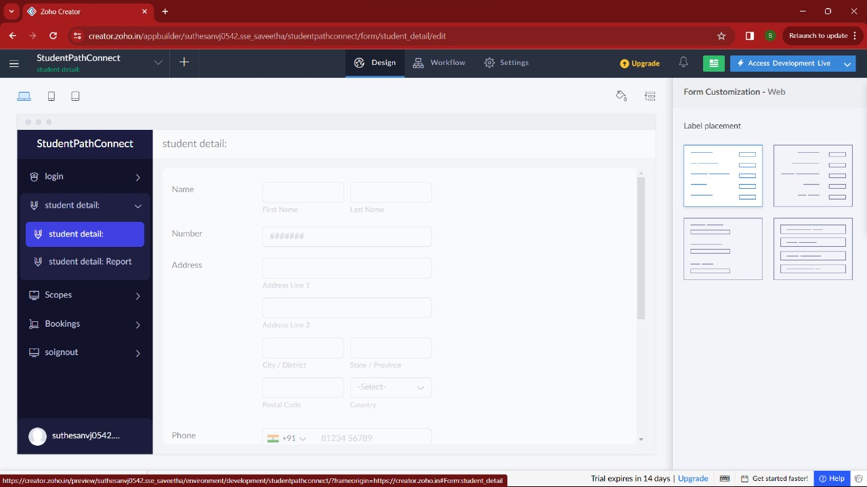

**STEP 06:** Next Form name is Scope For Domain Selection For Student.

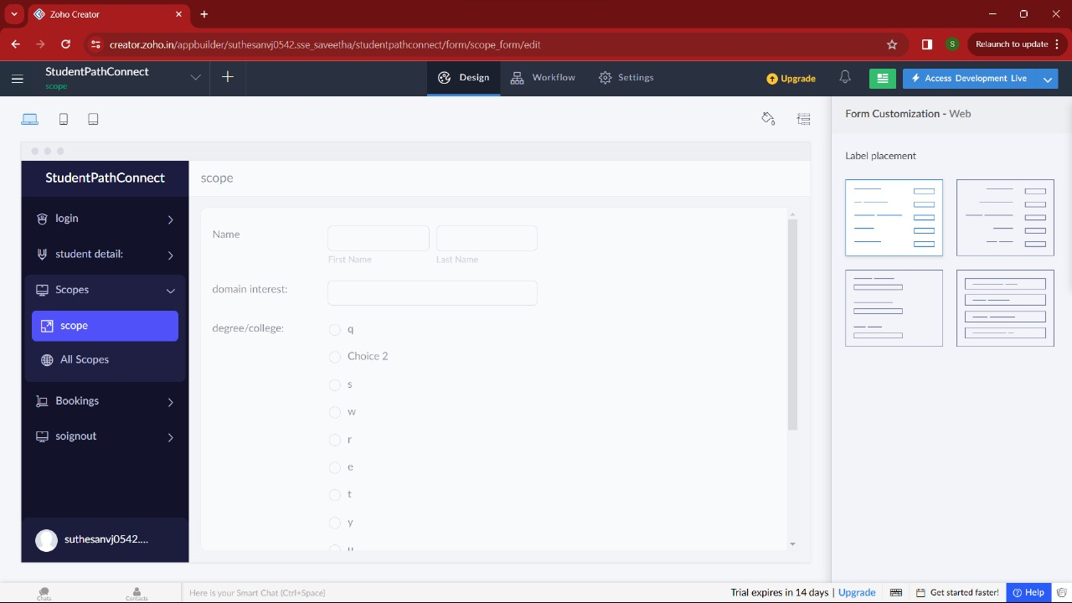

**STEP 07:** After Enter the Student Details and after select the Student Domain and college Confirm Booking By using this Form .

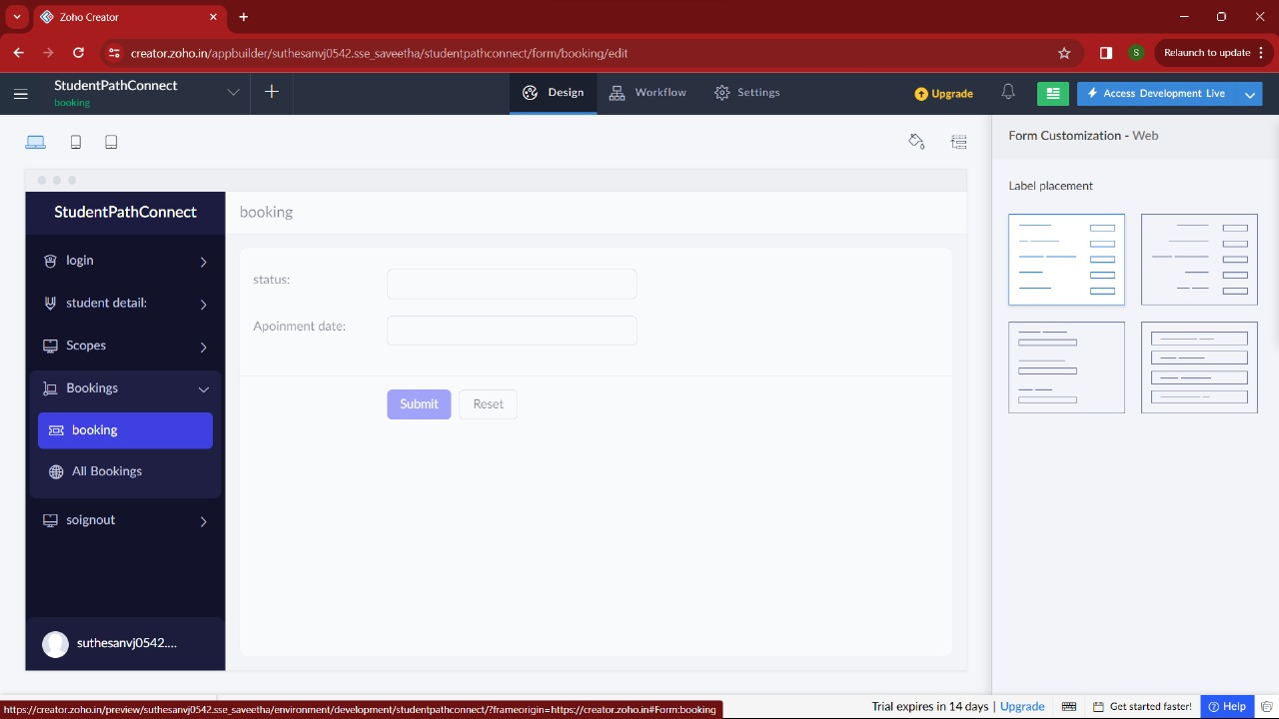

**STEP 08 :** After Complete The Counselling Process This Form Will be came For Logout.

